Problem 12.20

(Term Project) Using the technique specified by your instructor, draw up a specification document for the Chocoholics Anonymous product described in Appendix A.

Step-by-step solution

1. **Step 1** of 9

A solution using Gane and Sarsen’s method is given.

*Step 1.  Draw the data flow diagram*.

To simplify the data flow diagram, it is drawn in three parts.  Data stores and external agents are repeated, but there is only one instance of each process.  The data flow dia­grams appear in Figures 12.7(a), 12.7(b) and 12.7(c).

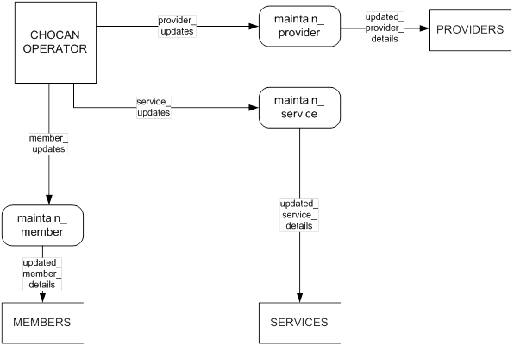

Figure 12.7(a).  Part 1 of data flow diagram for Chocoholics Anonymous.

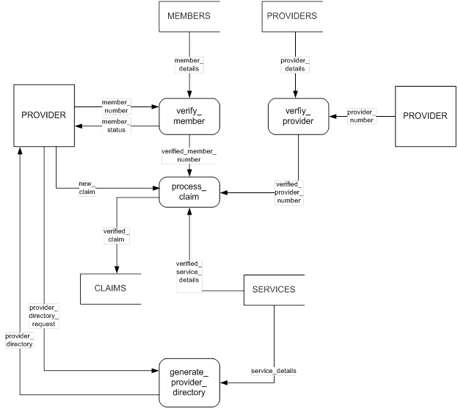

Figure 12.7(b).  Part 2 of data flow diagram for Chocoholics Anonymous.

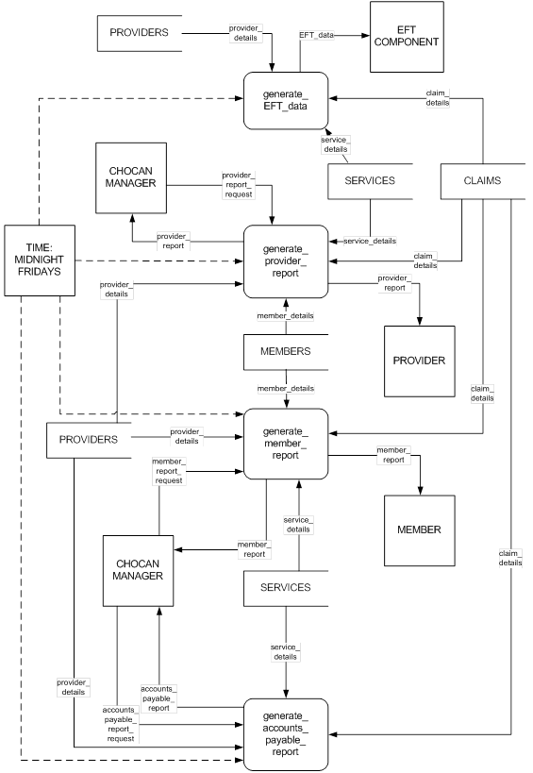

Figure 12.7(c).  Part 3 of data flow diagram for Chocoholics Anonymous.

[Comment](javascript:;)

1. **Step 2** of 9

*Step 2.  Decide what sections to computerize, and how*.

 All processes shown in the DFD will be computerized.  A central database is required, installed on a server at the ChocAn Data Center.  A client-server architecture is required for online implemention of the processes shown in Part 1 of the DFD (maintenance of the data­base by a ChocAn operator).  The processes shown in Part 2 of the DFD will be imple­mented using provider terminals that interact with the server via a dial-up modem.  The processes shown in Part 3 of the DFD will be implemented firstly as batch processes that will be run at midnight each Friday.  This is indicated by the dashed lines (control flows) in the DFD.  Secondly, a single report can be generated at any time interactively on request by the ChocAn manager from a client workstation.

[Comment](javascript:;)

1. **Step 3** of 9

*Step 3. Put in the Details of the Data Flows*

provider_details provider number (max 9 digits) (generated by system, may not be changed) provider name (max 25 characters) provider street address (max 25 characters) provider city (max 14 characters) provider state (2 letters) provider zip code (5 digits) provider email address (max 50 characters) provider type (1 letter, see below) Dietitian (D), Internist (I) or Exercise Specialist (E)provider_updates:

For a new provider: provider details excluding provider number To update an existing provider: existing provider number updated provider details excluding provider number

To delete an existing provider: provider numberupdated_provider_details: provider_details member_details: member number (max 9 digits) (generated by system, may not be changed) member name (max 25 characters) member street address (max 25 characters) member city (max 14 characters) member state (2 letters) member zip code (5 digits) member email address (max 50 characters) member status (1 letter, see below) Active (A) or Suspended (S)member_updates: For a new member: member details excluding member number To update an existing member: existing member number updated member details excluding member number To delete an existing member: member numberupdated_member_details: member_detailsservice_details: service code (max 6 digits) service name (max 20 characters) service fee (4 + 2 digits)service_updates: For a new service: service details To update an existing service: existing service code updated service details To delete an existing service: service codeupdated_service_details: service_detailsclaim_details: submission date and time (19 characters, format MM-DD-YYYY HH:MM:SS) service date (10 characters, format MM-DD-YYYY) provider number (max 9 digits) member number (max 9 digits) service code (max 6 digits)new_claim: claim_detailsverified_provider_number: provider_numberverified_member_number: member_numberverified_sevice_details: service_detailsverified_claim: claim_detailsprovider_directory_request (1 character)provider_directory: For each service, alphabetically ordered according to service name: service name (max 20 characters) service code (max 6 digits) service fee (4 + 2 digits)provider_report_request: provider number (max 9 digits) end date of week (10 characters, format MM-DD-YYYY)provider_report: provider name (max 25 characters) provider number (max 9 digits) provider street address (max 25 characters) provider city (max 14 characters) provider state (2 letters) provider zip code (5 digits) For each service provided, sorted according to claim submission date and time: service date (10 characters, format MM-DD-YYYY) submission date and time (19 characters, format MM-DD-YYYY HH:MM:SS) member name (max 25 characters) member number (max 9 digits) service code (max 6 digits) service fee (4 + 2 digits) total number of consultations (3 digits) total fee for week (5 + 2 digits)member_report_request : member number (max 9 digits) end date of week (10 characters, format MM-DD-YYYY)member_report: member name (max 25 characters) member number (max 9 digits) member street address (max 25 characters) member city (max 14 characters) member state (2 letters) member zip code (5 digits) For each service provided, sorted according to service date: service date (10 characters, format MM-DD-YYYY) provider name (max 25 characters) service name (max 20 characters)accounts_payable_report_request: end date of week (10 characters, format MM-DD-YYYY)accounts_payable_report: For each provider to be paid that week: provider name (25 characters) number of consultations (max 6 digits) total fee (5 + 2 digits) total number of providers (max 6 digits) total number of consultations (max 9 digits) overall total fee (6 + 2 digits)EFT_data For each provider to be paid: provider name (max 25 characters) provider number (max 9 digits) total fee for week (5 + 2 digits)

[Comment](javascript:;)

1. **Step 4** of 9

*Step 4.  Define Logic of Processes*

maintain provider

 To add a new provider:

Insert the provider details excluding provider number into the database.

The database must generate a provider number for the new provider.

 To update an existing provider:

  Search for the existing provider using the provider number.

  Update the provider details.

 To delete an existing provider:

  Search for the existing provider using the provider number.

  Delete the provider details.

maintain member

 To add a new member:

Insert the member details excluding member number into the database.

The database must generate a member number for the new member.

 To update an existing member:

  Search for the existing member using the member number.

  Update the member details.

 To delete an existing member:

  Search for the existing member using the member number.

  Delete the member details.

maintain service

 To add a new service:

Insert the service details into the database.

 To update an existing service:

  Search for the existing service using the service code

  Update the service details.

 To delete an existing service:

  Search for the existing service using the service code

  Delete the service details.

verify provider

 Search for the provider number in the database.

verify member

 Search for the member number in the database.

 Determine if member status is Active.

process claim

 Search for the service code in the database.

 Insert the verified claim into the database.

generate provider directory

 Extract provider directory data from database.

generate EFT data

 Extract EFT data from database.

generate provider report

 Extract provider report data from database.

generate member report

 Extract member report data from database.

generate accounts payable report

 Extract accounts payable report data from database.

[Comment](javascript:;)

1. **Step 5** of 9

*Step 5.  Define the data stores*

PROVIDERS DATA

 provider details — defined in step 3.

MEMBERS DATA

 member details – defined in step 3.

SERVICES DATA

 service details — defined in step 3.

CLAIMS DATA

 claim details – defined in step 3.

[Comment](javascript:;)

1. **Step 6** of 9

*Step 6.  Define physical resources*

Use a relational database with a separate table for each of the data stores defined above.

PROVIDER TABLE

Primary key: provider number

MEMBER TABLE

 Primary key: member number

SERVICE TABLE

Primary key: service code

Secondary index: service name

CLAIM TABLE

 Primary key: submission date and time

 Foreign key: provider number

 Foreign key: member number

 Foreign key: service code

 Secondary index: service date

[Comment](javascript:;)

1. **Step 7** of 9

*Step 7.  Determine input/output specifications*

The content of input screens and reports and the format of fields has been determined in step 3.

Input screens will be designed for the following processes:

(ChocAn operator interface)

maintain provider

maintain member

maintain service

(ChocAn manager interface)

 generate provider report

 generate member report

 generate accounts payable report

A command line interface (user dialogue for the provider terminal) will be designed for the fol­lowing processes:

 verify provider (when the terminal is switched on)

 verify member

 process claim

 request provider directory

The layout of the following reports will be designed:

 provider report

 member report

 accounts payable report

 provider directory

The exact format of the EFT data must be determined for the following process:

 generate EFT data

[Comment](javascript:;)

1. **Step 8** of 9

*Step 8 . Perform Sizing*

Database:

Provider table: approximately 124 to 132 bytes for each record.

 ChocAn has about 100 providers currently and expects a growth of 10 percent.

 Thus the provider table needs approximately 15 kilobytes of storage.

Member table: record sizes are equivalent to provider records.

 ChocAn has about 1000 members currently and expects a growth of 20%.

 Thus the member table needs approximately 160 kilobytes of storage.

Service table: approximately 32 bytes for each record.

 There are currently about 50 different services available.  Making provision for a growth of 25%, approximately 2 kilobytes of storage are required.

Claim table: approximately 52 bytes for each record.

 On average, each member visits a provider twice a week.  The expected number of claims per year is thus 124800.  Approximately 7 megabytes are required for the claim table.

Software:

 A Database Management System (DBMS) can require 10 to 500 megabytes, or more, of storage.

 The application programs that must run on the server will require approximately 2 megabytes of storage.  Middleware is also necessary so that the server and clients can interact.  This will also require a few megabytes of storage.

Assuming a DBMS of approximately 75 megabytes, 100 megabytes of storage on the server should be sufficient.  Client workstations need only enough storage to run the interface programs.  This will be only a few megabytes.  Provider terminals will need even less storage space because the software will include a command line interface, not a graphical user interface.

[Comment](javascript:;)

1. **Step 9** of 9

*Step 9.  Determine the Hardware Requirements*

 One server will be required for the database.  At least two terminals are needed for ChocAn operators for the maintenance of data, and at least one more is needed for the manager to run reports.  At least one printer will be needed for the manager to print reports.  Each provider will need a provider terminal (at least 110).  It is assumed that each provider will use his own computer to receive email, including provider reports and the provider directory.

[Comment](javascript:;)